Lab 4:

Task1:

1_ enp03()

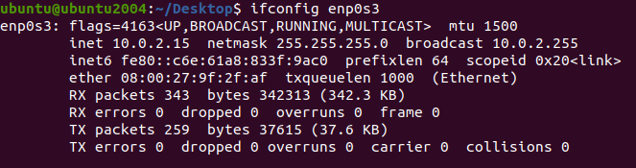

2_ all the interface:

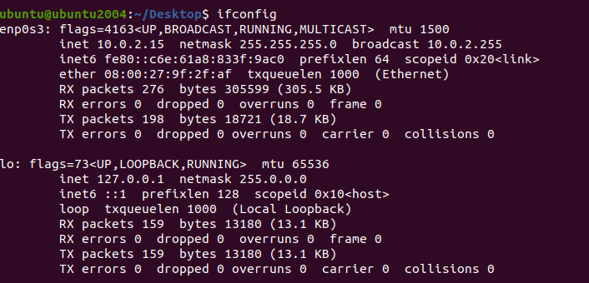

3_ setting up and down:

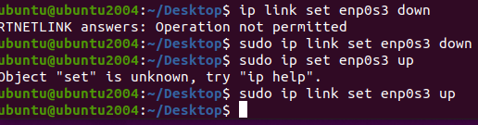

Task 2:

1_curnet IP route:

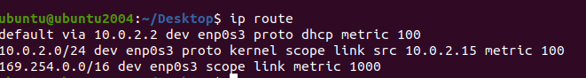

2_adding route and show:

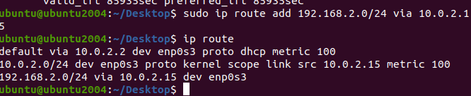

3_deleting the route :

